 | Sample Application Supply Chain Management Architecture  Document Status: WS-I Working Group Draft  Version: 0.11  Date: December 19, 2002  Editors: Martin Chapman, Oracle  Marc Goodner, SAP  Brad Lund, Intel  Barbara McKee, IBM  Rimas Rekasius, IBM

Notice

The material contained herein is not a license, either expressly or impliedly, to any intellectual property owned or controlled by any of the authors or developers of this material or WS-I. The material contained herein is provided on an "AS IS" basis and to the maximum extent permitted by applicable law, this material is provided AS IS AND WITH ALL FAULTS, and the authors and developers of this material and WS-I hereby disclaim all other warranties and conditions, either express, implied or statutory, including, but not limited to, any (if any) implied warranties, duties or conditions of merchantability, of fitness for a particular purpose, of accuracy or completeness of responses, of results, of workmanlike effort, of lack of viruses, and of lack of negligence. ALSO, THERE IS NO WARRANTY OR CONDITION OF TITLE, QUIET ENJOYMENT, QUIET POSSESSION, CORRESPONDENCE TO DESCRIPTION OR NON-INFRINGEMENT WITH REGARD TO THIS MATERIAL.

IN NO EVENT WILL ANY AUTHOR OR DEVELOPER OF THIS MATERIAL OR WS-I BE LIABLE TO ANY OTHER PARTY FOR THE COST OF PROCURING SUBSTITUTE GOODS OR SERVICES, LOST PROFITS, LOSS OF USE, LOSS OF DATA, OR ANY INCIDENTAL, CONSEQUENTIAL, DIRECT, INDIRECT, OR SPECIAL DAMAGES WHETHER UNDER CONTRACT, TORT, WARRANTY, OR OTHERWISE, ARISING IN ANY WAY OUT OF THIS OR ANY OTHER AGREEMENT RELATING TO THIS MATERIAL, WHETHER OR NOT SUCH PARTY HAD ADVANCE NOTICE OF THE POSSIBILITY OF SUCH DAMAGES.

Status of this Document

This document is a Working Group Draft; it has been accepted by the Working Group as reflecting the current state of discussions. It is a work in progress, and should not be considered authoritative or final; other documents may supercede this document.

Table of Contents
1 Introduction 4
2 Document References 5
3 Retailer System Architecture 5
3.1 Retailer System Glossary 5
3.2 Retailer System Overview 6
3.3 Deployment Diagram 6
3.4 Retailer System Web services 7
3.4.1 Retailer Service 8
3.4.2 Warehouse Service 9
3.4.3 Warehouse Callback Service 10
3.4.4 WSDL 11
3.5 Class Diagram 12
3.6 Sequence Diagrams 12
3.6.1 UC1: Purchase Goods 12
3.6.2 UC2: Source Goods 13
3.6.3 UC3: Replenish Stock 13
4 Manufacturing System Architecture 14
4.1 Manufacturing System Glossary 14
4.2 Manufacturing System Overview 15
4.3 Deployment Diagram 15
4.4 Manufacturing System Web services 16
4.4.1 Manufacturer Service 16
4.4.2 WSDL 17
4.5 Class Diagram 17
4.6 Sequence Diagrams 18
4.6.1 UC4: Supply Finished Goods & UC5: Manufacture Finished Goods 19
5 Demo System Architecture 19
5.1 Demo System Glossary 20
5.2 Sample Application Flow 20
5.3 Deployment Diagram 21
5.4 Demo System Web services 22
5.4.1 Configurator 23
5.4.2 Configurator WSDL 24
5.4.3 Logging Facility 24
5.4.4 Logging Facility WSDL 26
5.5 Class Diagram 26
5.6 Sequence Diagrams 27
5.6.1 UC6: Configure & Run Demo 27
5.6.2 UC7: Log Events 28
5.6.3 UC8: View Events 29
6 Design Aspects of the Basic Sample Application 29
6.1 Basic Sample Application User Interface Fundamentals 29
6.2 Basic Sample Application Web Service Descriptions 30
6.3 UDDI Advertisement of the Basic Sample Application 31
6.3.1 Advertisement of tModels 31
6.3.2 Advertisement of Web Service Implementations 33
6.3.3 Participation in the WS-I Interoperability Showcase 35
6.3.4 businessService Categorizations To Differentiate Roles 35
6.4 Event Logging in the Basic Sample Application 35
6.5 State Data Used by the Basic Sample Application 37

Introduction
This document details the technical design and implementation of the Basic Profile 1.0 Sample Application. The sample application described herein was modeled after the “simple” supply chain management (SCM) application outlined in the SCM Use Cases V1.0 document; it is not intended to exhibit all of the characteristics of a real world SCM design and implementation. Rather, it serves to document and demonstrate how WS-I Basic Profile 1.0 conformant web services might be designed, implemented and deployed.
One of the goals of the Sample Application is to explore as many of the features found in the Basic Profile as possible. To this end, the sample application employs a variety of schema naming conventions, SOAP message formats, SOAP message styles, and WSDL design practices that are all Basic Profile conformant. In many places coverage of Basic Profile features has been traded for best practice.
To fully understand the contents of this document it is highly recommended that the SCM Use Cases v 1.0 as well as the Usage Scenarios v 1.0 documents be consulted in conjunction with this document. A quick overview of the various stages of interactions for the Sample Application can be found in section 5.2, Figure 9.
In order to inject some realism into the sample application, a single top down design was not attempted. Rather each main system (Retailer, Manufacture, Demo) has been designed and architected separately and brought together via web services. This should reflect the real world of connecting autonomous organizations together without the luxury of a global architecture and design.
The document is divided into four main sections and has an intended audience which includes Architects, Designers and Implementers of WS-I compliant web services. Each section of this document starts with a glossary of terms used to help clarify specific areas of discussion.
Section 3, “Retailer System Architecture”: This section provides an in-depth look at the various web services and associated methods required for a consumer to order product and simultaneously receive a response indicating which items were shipped. Additionally, this section describes a web service that is invoked by the retailer’s warehouse which checks each line item in the order for product availability.
Included in this section are several architectural diagrams that provide different views of the application mechanics, including interfaces, roles and responsibilities, business rules to help facilitate WSDL design, processes as well as the information collected and maintained. Also, the reader will discover which usage scenarios were implemented as well as the recommended message style.
Section 4, “Manufacturing System Architecture”: Here we look at the various web services and associated methods required to supply finished goods to the warehouses. Like Section 3, this section contains detailed architectural mechanics, usage scenario and message style selection as they relate to the manufacturing architecture.
Section 5, “Demo System”: This section examines how various use cases were implemented in the development of the demo application that will be showcased on the WS-I web site. Section 5.2 provides the reader with a step-by-step roadmap of the processes involved to interact with the demo. Like previous sections, this section contains detailed architectural mechanics, usage scenario and message style selection as they relate to specific pieces of the demo application.
Section 6. “Design Aspects of the Basic Sample Application”: This section describes the technical design aspects of the Basic Sample Application. The technical descriptions of the Web services and their associated schemas are included here, as are the fundamentals of the showcase User Interface, logging of events, fixed sample data, and the advertisement of sample Web services in UDDI. The reader will find several examples of XML code to assist them in the UDDI registration of their web services.

Document References
Document | Description
Usage Scenarios | This document describes Usage Scenarios, as defined by the Scenarios and Design Sub-team of the Basic Sample Applications Workgroup for the WS-I.
SCM Use Cases | This document contains the use cases on which this Architecture and Domain Model has been based.

Retailer System Architecture
This section pertains to the technical design and implementation of the Basic Profile Sample Application. In particular it defines the Retailer part of the system defined in the SCM use case document.
The domain model and architecture described in this section relates to the retailer system and its related use cases as defined in the SCM Use Cases v 1 document, and as such should be read in conjunction with that document.
The various types of diagrams (class, sequence, deployment, etc.) included in this section each provide a different view of the application, including its interfaces, roles and responsibilities, business rules, processes as well as the information collected and maintained.
In general this model is implementation independent except where technical constraints are given as part of the requirements.

Retailer System Glossary
Term | Description
Catalog | A listing of catalog entries
Catalog Entry | The details about a product (name, description, category, price, etc)
Consumer | A party that wishes to purchase product from a Retailer
Inventory Item | The details of a product as it relates to a warehouse (product code, warehouse location, number in stock, minimum stock level, maximum stock level)
Line Item | An entry in an order relating to a single product (product code, required quantity)
Manufacturer | A party that supplies finished goods to a Retailer’s warehouses.
Order (or Purchase Order/PO) | A request from a Consumer asking to purchase products. An order consists of one or more line items
Product | A tangible entity that can be sold – finished goods
Shipping Notice (SN) | A notice sent to a consumer in response to a purchase order stating that the line items have been shipped.
Retailer | A party that offers products for sale
Warehouse | An entity that stores products and maintains an Inventory level for each stocked product

Retailer System Overview
The Retailer will present a Web service for some third party system to access its services. In the Sample Application this will be the Demo System. The Retailer web service provides a façade onto the Retailer System, providing operations to access the catalog of products and to place orders. Within the Retailer System there are three instances of the warehouse web services, one for each of warehouse A, B and C defined in the Use Case document. These warehouses will in turn call out to the three Manufacturing systems, whose architecture is defined in Section 4. To facilitate this interaction the warehouse has to provide a callback interface – these and the retailer web service are the only external entry points into the Retailer system. For the purpose of the Sample Application the Retailer System relies on the Logging service provided by the Demo System.

Deployment Diagram
Error: Reference source not found Figure 1 shows a conceptual view of an implementation of a Retailer System.

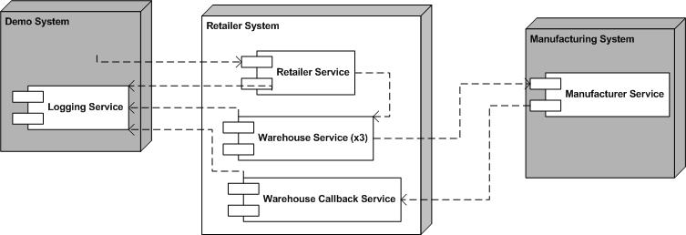
Figure 1: Retailer System Deployment Diagram

Retailer System Web services
The operations, message types and other relevant information for each Web service are outlined in the sections below. These sections specify key details to be defined in the associated WSDL files. The exact structure of these files is to be resolved as part of the implementation of this sample application.
The Retailer System will contain the following web services:
- Retailer Service
- Warehouse Service
- Warehouse Callback Service.

In addition, the Retailer System depends on two other services external to itself and defined elsewhere:
Logging Service - defined in the Demo System section.
Manufacturer Service – defined in the Manufacturing System section.
Profiles
The web services will be based on the WS-I Basic Profile V1.0.
Usage Scenarios
The web services in the retailer system will rely on the following usage scenarios (refer to Usage Scenarios document):
- Synchronous Request/Response
- Basic Callback
- One-way

Retailer Service
Operations/Message Types
The following operations/message types should be supported, and shall follow the synchronous request/reply scenario:
Operation | Msg. Type | Message | Parameters | Type
submitOrder | Input | submitOrderRequest | PartsOrder | PartsOrderType
 |  |  | Customer Details | CustomerDetailsType
 |  |  | ConfigurationHeader | Configuration
 | Output | submitOrderResponse | Response | PartsOrderResponseType
 | Fault | BadOrder |  | Client
 | Fault | InvalidProductCode |  | Client
 | Fault | ConfigurationFault |  | Client

Operation | Msg. Type | Message | Parameters | Type
getCatalog | Input | getCatalogRequest
 | Output | getCatalogResponse | return | CatalogType

submitOrder
Description
Refer to UC (Use Case)1 and UC2. The consumer submits an order and receives a response indicating which goods will be shipped. To determine which goods can be shipped Warehouse A, B, and C are asked in turn (see warehouse service).
A BadOrder fault is returned if the order is malformed and cannot be interpreted, or contains no line items.
An order is rejected, with an InvalidProductCode fault, if it contains a line item with an invalid (i.e. unknown) product code.

A ConfigurationFault fault is returned if there is a problem in the configuration header.
Scenario
The scenario used will be Synchronous Request/Response using SOAP over HTTP.
Message Style
The rpc/literal message style will be used.

getCatalog
Description
Refer to UC1. A call to this operation results in the Retailer sending over the list of products that it sells, this list would need to be rendered in order to present to a user. There are no input parameters as there is no choice of catalogs or parts of a catalog.
Scenario
The scenario used will be Synchronous Request/Response using SOAP over HTTP.
Message Style
The the rpc/literal message style will be used.

Warehouse Service
Operations/Message Types
The following operations/message types should be supported, and all shall follow the synchronous request/reply scenario:
Operation | Msg. Type | Message | Parameters | Type
ShipGoods | Input | ShipGoodsRequest | ItemList | ItemList
 |  |  | Customer | CustomerReferenceType
 |  |  | ConfigurationHeader | Configuration
 | Output | ShipGoodsResponse | Response | ItemShippingStatusList
 | Fault | ConfigurationFault |  | Server

ShipGoods
Description
Refer to UC 1 and UC2. A call to this service results in the warehouse checking each line item in the order. If for each line item the required quantity is in stock, the warehouse will ship that line item (and hence reduce the stock level). It will record which ones it has shipped and which ones it does not have enough stock for and hence cannot ship; the response will contain this list.
A ConfigurationFault fault is returned if there is a problem in the configuration header.
The reduction of the stock level below the minimum level will trigger the warehouse to call on the Supply service of the relevant manufacturer (defined in the Manufacturing System Domain Model and Architecture section).
Scenario
The scenario used will be Synchronous Request/Response using SOAP over HTTP.
Message Style
The rpc/literal message style will be used.

Warehouse Callback Service
Operations/Message Types
The following operations/message types should be supported:
Operation | Msg. Type | Message | Parameters | Type
SubmitSN | Input | SNSubmit | shippingNotice | doc
 |  |  | ConfigurationHeader | Configuration
 |  |  | CallbackHeader | CallbackHeader
 | Output | ackSN | Response | boolean
 | Fault | ConfigurationFault |  | Client
 | Fault | CallbackFault |  | Server

Operation | Msg. Type | Message | Parameters | Type
ErrorPO | Input | ProcessPOFault | ProcessPOFault | SubmitPOFault
 | Output | AckPO | Repsonse | boolean
 | Fault | ConfigurationFault |  | Client
 | Fault | CallbackFault |  | Server

SubmitSN
Description
Refer to UC3 and UC4. A call to this service indicates that the manufacturer has finished processing an order.
If the manufacturer’s processing has been successful, the manufacturer will submit the shipping notice using the SubmitSN operation. If the shipping notice can be correlated to an order placed with a manufacturer, a positive acknowledgement is sent in the reply; otherwise a callbackfault is returned.
In this version of the sample application, all responses will cause the Manufacturer to consider the order request complete i.e. no further processing of the order will take place.

Scenario
The scenario used will be the reply/callback portion of the Basic Callback Scenario using SOAP over HTTP.
Message Style
The doc/literal message style will be used.

ErrorPO
Description
Refer to Use cases 3 and 4. A call to this service indicates that the manufacturer has finished processing an order but there had been an error in doing so.
If the Manufacturer’s processing of the order has not been successful, the Manufacturer will provide a reason using the ErrorPO operation.
For any PO, a Manufacturer may only invoke one of submitSN or ErrorPO.
Scenario
The scenario used will be the reply/callback portion of the Basic Callback Scenario using SOAP over HTTP.
Message Style
The doc/literal message style will be used.

WSDL
The Retailer Service is defined by two schemas and one WSDL document. The schemas are imported into the types section of the WSDL.

WSDL
http://www.ws-i.org/SampleApplications/SupplyChainManagement/2002-08/Retailer.wsdl
Schema
http://www.ws-i.org/SampleApplications/SupplyChainManagement/2002-08/RetailOrder.xsd
http://www.ws-i.org/SampleApplications/SupplyChainManagement/2002-08/RetailCatalog.xsd

Because the Retailer uses and passes showcase configuration information to Warehouses in a Configuration header, the Retailer also imports a Configuration WSDL and schema. The Configuration Header Fault is described in the WSDL, and the data types used in the Configuration header and header fault are described in the schema.

WSDL
http://www.ws-i.org/SampleApplications/SupplyChainManagement/2002-08/Configuration.wsdl
Schema
http://www.ws-i.org/SampleApplications/SupplyChainManagement/2002-08/Configuration.xsd

The Warehouse Callback Service is defined as part of the Manufacturing system and consists of one schema and one WSDL document.
WSDL
http://www.ws-i.org/SampleApplications/SupplyChainManagement/2002-08/Manufacturer.wsdl
Schema
http://www.ws-i.org/SampleApplications/SupplyChainManagement/2002-08/ManufacturerPO.xsd

Class Diagram
The class diagram below describes the different types of objects and data elements involved in the retailer system and the relationships that exist among them. It serves to define the vocabulary of the system and helps to define the schemas. This is a conceptual diagram and is not meant to impose any structure on implementations.

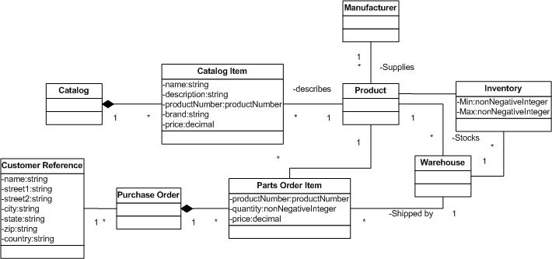
Figure 2: Class Diagram for the Retailer System

Sequence Diagrams
The sequence diagrams below describe how the groups of objects interact with each other.

UC1: Purchase Goods
Use Case 1 maps to the interactions between the invoker (a retailer provided web page) and the Retailer Service.
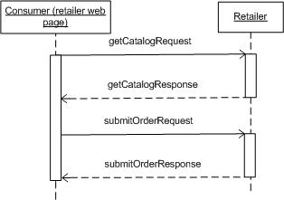
Figure 3:Sequence diagram for Use case 1 and the relevant web services

UC2: Source Goods
Use Case 2 maps to the interactions between the Retailer Service and Warehouse Services A, B, and C.
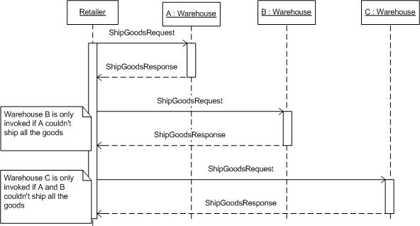
Figure 4:Sequence Diagram for Use Case 2 and the relevant Web services

UC3: Replenish Stock
Use case 3 maps to the interactions between a warehouse and a manufacturer (Figure 5Error: Reference source not found). Use case 4 describes the manufacturer side of this interaction.
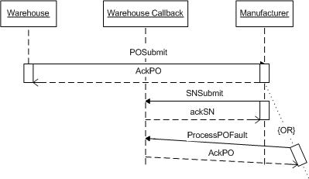
Figure 5: Sequence Diagram for Use Case 3 and the relevant Web services

Manufacturing System Architecture
This section pertains to the technical design and implementation of the Manufacturer System of the Basic Profile Sample Application as specified in the SCM Use Cases v 1 document.
The domain model described in this section relates to the following use cases outlined in the SCM Use Cases v 1 document, and as such should be read in conjunction with that document:
- UC4: Supply Finished Goods
- UC5: Manufacture Finished Goods
The various types of diagrams (class, sequence, deployment, etc.) included in this section each provide a different view of the application, including its interfaces, roles and responsibilities, business rules, processes as well as the information collected and maintained.
In general this model is implementation independent except where technical constraints are given as part of the requirements.

Manufacturing System Glossary
Term | Description
Inventory Item | The details of a product as it relates to availability (product code, number in stock)
Line Item | An entry in an order relating to a single product (product code, required quantity)
Manufacturer | A party the supplies finished goods to a purchaser.
Product | A tangible entity that can be sold, finished goods
Purchaser | Party requesting finished goods.
Purchase Order | A request from a purchaser to buy products consisting of one or more line items

Manufacturing System Overview
The Manufacturing system supplies finished goods to warehouses. Requests for finished goods may be fulfilled by the Manufacturer by supplying from internal stock or, if the required quantity is not available, by scheduling a production run. Since there could be a considerable time delay between receiving the order and informing the warehouse of shipment of goods, an asynchronous processing model is used. This allows a warehouse to proceed on other business, and allows the Manufacturer to callback to the Warehouse once the order has been fulfilled.

Deployment Diagram
Below is a conceptual view of an implementation.
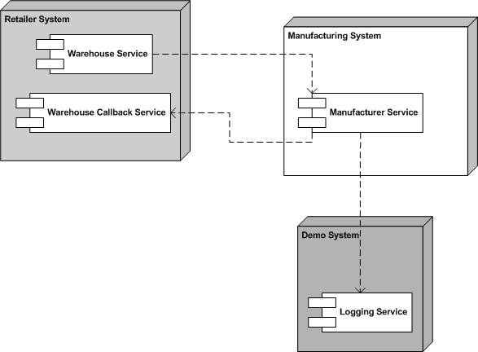
Figure 6:Deployment diagram for the Manufacturing System

Manufacturing System Web services
The operations, message types and other relevant information for each Web service are outlined in the sections below. These sections specify key details to be defined in the associated WSDL files. The exact structure of these files is to be resolved as part of the implementation of the sample application.
The Manufacturer System portion of the sample application will contain the following web services:
- Manufacturer Service
Profiles
The web services will be based on the WS-I Basic Profile V1.0.
Usage Scenarios
The web services in the sample application will rely on the following usage scenarios (refer to Usage Scenarios document):
- Synchronous Request/Reply
- Basic Callback

Manufacturer Service
Operations/Message Types
The following operations/message types should be supported:
Operation | Msg. Type | Message | Parameters | Type
submitPO | Input | POSubmit | PurchaseOrder | doc
 |  |  | ConfigurationHeader | Configuration
 |  |  | StartHeader | StartHeader
 | Output | ackPO | Response | boolean
 | Fault | POFault |  | Client
 | Fault | ConfigurationFault |  | Client

submitPO
Description
The purpose of this operation is to place a purchase order with the manufacturer for finished goods. PurchaseOrder is a set of line items describing ordered finished goods (see class diagram). StartHeader is detailed in the Basic Callback Scenario. This message header contains a callback location and message identifier to be retained by the system for sending the shipping notification in the final request/response. Response is a tacit acknowledgement that the purchase order was received and validated. If the purchase order is invalid for any reason, a POFault is sent to the client.
Scenario
The scenario used will be the initial request/response portion of the Basic Callback Scenario using SOAP over HTTP.
Message Style
The doc/literal message style will be used.

WSDL
The Manufacturer is defined by a schema and [part of] a WSDL document. The schema is imported into the types section of the WSDL. As mentioned above, the Manufacturer WSDL document contains two port types and bindings which together describe a single Web service type. The ManufacturerPortType and associated messages and bindings apply to the Manufacturer; the other applies to the Warehouse.

WSDL
http://www.ws-i.org/SampleApplications/SupplyChainManagement/2002-08/Manufacturer.wsdl
Schema
http://www.ws-i.org/SampleApplications/SupplyChainManagement/2002-08/ManufacturerPO.xsd

Because the Manufacturer uses and passes showcase configuration information to Warehouses in a Configuration header, the Manufacturer also imports a Configuration WSDL and schema. The Configuration Header Fault is described in the WSDL, and the data types used in the Configuration header and header fault are described in the schema.

WSDL
http://www.ws-i.org/SampleApplications/SupplyChainManagement/2002-08/Configuration.wsdl
Schema
http://www.ws-i.org/SampleApplications/SupplyChainManagement/2002-08/Configuration.xsd

Class Diagram
The class diagram below describes the different types of objects and data elements involved in the manufacturing system and the relationships that exist among them. Is serves to define the vocabulary of the system and helps to define the schemas. This is a conceptual diagram and is not meant to impose any structure on implementations.
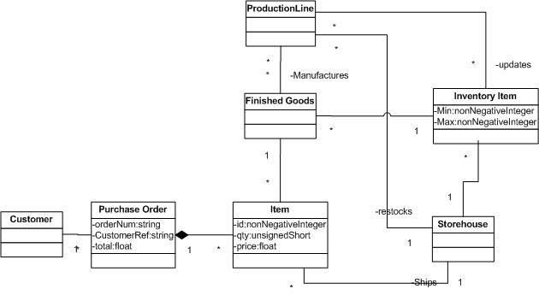
Figure 7: Manufacturer Class Diagram

Sequence Diagrams
The sequence diagrams below describe how the groups of objects interact with each other. The diagram below shows the behavior of both Use Case 4 and Use Case 5. See also the Retailer System, Section 3.6.3.

UC4: Supply Finished Goods & UC5: Manufacture Finished Goods
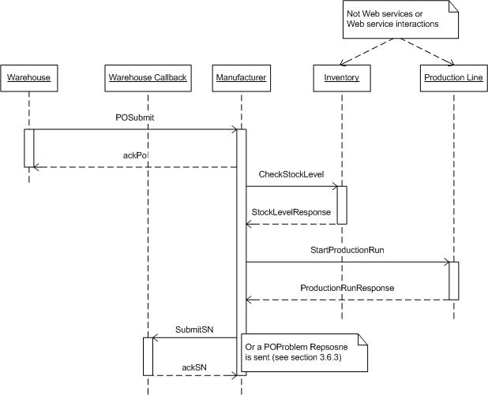
Figure 8:Manufacturer Sequence Diagram

Demo System Architecture
This section pertains to the technical design and implementation of the Demo System of the Basic Profile Sample Application as specified in the SCM Use Cases v 1 document.
The domain model described in this section relates to the following use cases outlined in the SCM Use Cases v 1 document, and as such should be read in conjunction with that document:
- UC6: Configure & Run Demo
- UC7: Log Events
- UC8: View Events

Demo System Glossary
Term | Description
Demo user | Person accessing WS-I web site for the purpose of trying out the sample application.
Configuration | Settings that allow demo user to direct which implementations to use in order to purchase goods, manufacture goods, order parts, etc.
Consumer | Person accessing the Retailer web site for the purpose of purchasing consumer electronics.

Sample Application Flow
Access to the sample application begins at the WS-I.org web site, which will be referred to as the “WS-I welcome” page. The welcome page will have a link to another web page hosted by the WS-I.org web site. This web page shall be called the “sample app” page. The sample app page will contain a description of the sample application, probably a link for obtaining the source code, and instructions for demonstrating how the sample application works. It will also contain one or more buttons or links for getting to the next web page called the “configuration” page.
The configuration page is where UC6: Configure & Run Demo begins. This page will present the demo user with a number of configuration options. These options select implementations for each of the web services in the sample application. Having made his/her selections, the demo user clicks on a “start a new demo” button, which brings the demo user to a web page where he/she can order products. We will call this the “shopping cart” page. This is where UC1: Purchase Goods begins. Before the demo user reaches the shopping cart page, a unique ID is generated to identify the events that are logged as a result of running the demo. This ID is necessary as it is entirely possible that more than one person may be running the demo at the same time. Such concurrent usage would result in log entries that might not make sense when viewed together, but when filtered based on ID they will illustrate the chain of events typical of a Supply Chain Management application.
On the shopping cart page, the demo user selects quantities of products to order, then clicks on a “submit order” button. This causes the demo system to invoke the Retailer web service. Once the Retailer has processed the order, the demo system displays the status of the order (i.e. how many and which products will be shipped). This is referred to as the “order status” web page. From the order status web page, the demo user may optionally select to view the events that occurred in the supply chain as a result of placing an order. This is done on the “track order” web page.
From either the order status page or the track order page, the demo user may return to the configuration page to start a new demo. The previous configuration will be presented as a default, but the demo user is free to change the configuration in order to test interoperability. Note that it is not possible for the demo user to return to the shopping cart page from either the order status page or the track order page. In other words, the only way for the demo user to go back and order more products is to return to the configuration page first. Figure 9 below presents a graphical representation of the flow of the sample application.
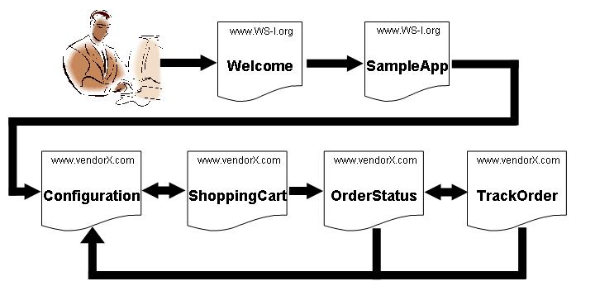
Figure 9:Sample Application Flow

Deployment Diagram
Figure 10 shows a conceptual view of an implementation.
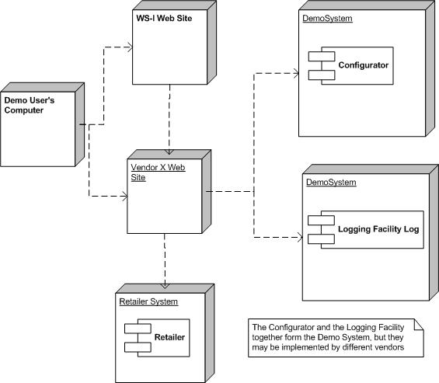
Figure 10: Demo System Deployment Diagram

Demo System Web services
This section identifies the Web services which will be used in the implementation of the previously described architecture of the sample application. The sample application will be composed of discovered Web services that utilize the usage patterns as captured in the Basic Profile Usage Scenarios document, and that conform to the various aspects of the Basic Profile.
The operations, message types and other relevant information for each Web service are outlined in the sections below. These sections specify key details to be defined in the associated WSDL files. The exact structure of these files is to be resolved as part of the implementation of the sample application.
The Demo System portion of the sample application will contain the following web services:
- Configurator
- Logging Facility
Profiles
The web services will be based on the WS-I Basic Profile V1.0.
Usage Scenarios
The web services in the sample application will rely on the following usage scenarios (refer to Usage Scenarios document):
- Synchronous Request/Response
- One-way

Configurator
Operations/Message Types
The following operations/message types should be supported:
Operation | Msg. Type | Message | Parameters | Type
getConfigurationOptions | Input | getConfigurationOptions | Refresh | Boolean
 | Output | getConfigurationOptionsResponse | Response | sequence of configOptions
 | Fault | configuratorFailedFault |  | Server

Operation Descriptions

getConfigurationOptions
Description
The purpose of this operation is to retrieve a list of all of the implementations registered in the UDDI registry for each of the web services in the sample application. Note that the implementation of the Configurator web service may choose to cache the results of the UDDI look-ups.
Parameters
Refresh – This is a flag which tells the Configurator web service whether or not the implementations should be looked up in UDDI. True = perform UDDI look-ups; false = perform UDDI lookup or return cached results (in other words false is a hint to implementations).
All implementations – This is what is returned to the caller if there was no error in accessing the UDDI registry or (optional) internal cache. It is a structure with multiple sections, one section for each “role” (i.e. web service type) in the sample application. Each section contains a list of structures, one structure for each implementation, containing the endpoint URL as well as the vendor name, platform and language for the registered implementations of that role.
configuratorFailedFault – This is a fault which is raised if there was an error in accessing the UDDI registry or (optional) internal cache (i.e. no implementations returned).
Scenario
The scenario used will be Synchronous Request/Response using SOAP over HTTP.
Message Style
The doc/literal message style will be used.

Configurator WSDL
The Configurator is defined by a schema and a WSDL document. The schema is imported into the types section of the WSDL.

WSDL
http://www.ws-i.org/SampleApplications/SupplyChainManagement/2002-08/Configurator.wsdl
Schema
http://www.ws-i.org/SampleApplications/SupplyChainManagement/2002-08/Configurator.xsd

The Configurator uses some of the data types defined for the Configuration header. The schema that defines the Configuration header is therefore imported.

Schema
http://www.ws-i.org/SampleApplications/SupplyChainManagement/2002-08/Configuration.xsd

Logging Facility
Operations/Message Types
The following operations/message types should be supported:
Operation | Msg. Type | Message | Parameters | Type
logEvent | Input | logEvent | DemoUserID | string
 |  |  | ServerID | string
 |  |  | EventDescription | string
 |  |  | EventId | string
 | Output | n/a | n/a | n/a

Operation | Msg. Type | Message | Parameters | Type
getEvents | Input | getEvents | DemoUserID | string
 | Output | getEventsResponse | Response | Sequence of LogEntry
 | Fault | RepositoryMissingFault |  | Server

Operation Descriptions

logEvent
Description
The purpose of this operation is to log an event that has occurred in one of the other systems in the sample application.
Parameters
DemoUserID – This is a string which identifies a demo user. The getEvents operation will retrieve all events for a specified DemoUserID.
ServerID – This is a string which identifies the server which requested the event to be logged.
EventDescription – This is a string which contains a description of the event being logged (e.g. “5 units of item X shipped from WarehouseB” or “10 units of item Y ordered from ManufacturerZ”).
Scenario
The scenario used will be one-way messaging using SOAP over HTTP.
Message Style
The doc/literal message style will be used.

getEvents
Description
The purpose of this operation is to retrieve all of the events that have occurred as the result of action taken by the demo user.
Parameters
DemoUserID – This is a string which identifies the demo user for whom events are being retrieved.
Response – This is what is returned to the caller as long as the repository is available. It is a sequence of structures, where each structure contains the following four items: Timestamp, ServerID, EventID and EventDescription. The last three items are exactly the same as those provided as input to the logEvent operation. The DemoUserID is not returned in the response as it was specified in the request.
RepositoryMissingFault – This is a fault which is raised if the repository used to store the log entries is unavailable for whatever reason.
Scenario
The scenario used will be Synchronous Request/Response using SOAP over HTTP.
Message
The message style used will be the doc/literal message style.

Logging Facility WSDL
The LoggingFacility is defined by a schema and a WSDL document. The schema is imported into the types section of the WSDL.

WSDL
http://www.ws-i.org/SampleApplications/SupplyChainManagement/2002-08/LoggingFacility.wsdl
Schema
http://www.ws-i.org/SampleApplications/SupplyChainManagement/2002-08/LoggingFacility.xsd

Class Diagram
The class diagram below describes the different types of objects and data elements involved in the demo system and the relationships that exist among them. Is serves to define the vocabulary of the system and helps to define the schemas. This is a conceptual diagram and is not meant to impose any structure on implementations.
Figure 11Error: Reference source not found below shows the different types of objects in the Demo system.
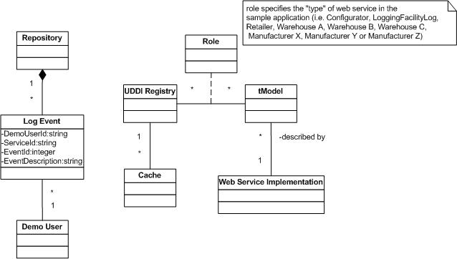
Figure 11:Class Diagram for Demo System

Sequence Diagrams
The sequence diagrams below describe how the groups of objects interact with each other. Each diagram shows the behavior of a single use case.

UC6: Configure & Run Demo
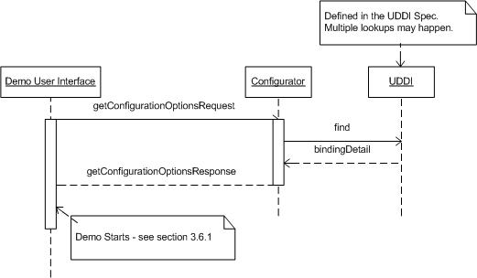
Figure 12: Sequence Diagram for UC6: Configure & Run Demo
When the demo user requests the demo URL, the DemoUI class calls the Configurator class to get the list of all possible implementations of each and every web service in the sample application. The Configurator class in turn calls the UDDI registry to look-up all of the implementations. The Configurator class may decide to cache the results of the look-ups.
Having received the list of all possible implementations, the DemoUI class then presents the choices to the demo user by displaying the configuration user interface (web page). The demo user then selects implementation options (presumably from drop-down list boxes, though other UI widgets may be used) and submits these selections back to the DemoUI class (presumably by pressing a “Submit Choices” button, though other UI widgets may be used).
When the DemoUI class receives the demo user’s selections, it generates an ID (which will be used for retrieving log events pertaining to the demo user), creates a Configuration SOAP Header ( which will be passed along to the other systems in the sample application), and then proceeds to display the product order web page.

UC7: Log Events
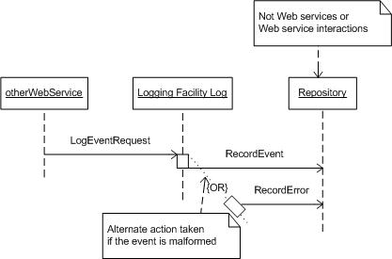
Figure 13: Sequence Diagram for UC7: Log Events
This use case is very simple and straight-forward: at some significant point in the execution of one of the other use cases in the Supply Chain Management sample application, a web service may decide to log the fact that some event has occurred in the system as a result of the demo user interacting with the Retail system. The calling web service collects all the information to be logged, and sends it to the logging facility using a one-way call (which is why the sequence diagram does not show a return from the logging facility back to the calling web service).
When the logging facility receives the request to log an event, it validates the request, and if the request is valid, proceeds to save the information sent to it in the log that it maintains. If the request is invalid, the logging facility will log the reason for the invalid request (e.g. message does not conform to schema). Of course, before saving a new entry in the log, the logging facility should check that the repository which it is using for storing the log entries is available. Different implementations will provide different qualities of service, but it is assumed that log entries will have a minimum life-span of one hour.

UC8: View Events
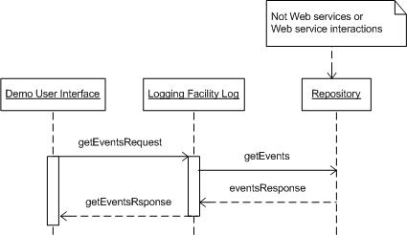
Figure 14: Sequence Diagram for UC8: View Events
The view events use case is initiated by the demo user navigating to the appropriate place in the user interface. This can be either a link or a button. Once the demo user has clicked on the button (or hyper-text), the user interface calls the logging facility to retrieve the log entries associated with the current demo user.
The logging facility accesses its repository of log entries, extracts the appropriate ones, and returns them to the user interface, which then displays them to the demo user. If for some reason the repository of log entries cannot be accessed, then a fault is returned to the user interface, and error message is displayed to the demo user.

Design Aspects of the Basic Sample Application

This section describes the technical design aspects of the Basic Sample Application. The technical descriptions of the Web services and their associated schemas are included here, as are the fundamentals of the showcase User Interface, logging of events, fixed sample data, and the advertisement of sample Web services in UDDI.

Implementations of WS-I Basic Sample Application Web services are provided by individual WS-I members. Some members may host live instances of their Web services. WS-I provides access to these hosted instances through a showcase version of the Basic Sample Application that can be launched from the WS-I Web site.

Basic Sample Application User Interface Fundamentals

One or more front ends to the Basic Sample Application may be implemented by WS-I member companies. These contributors may host live instances of their front ends which can be accessed from the the WS-I interoperability showcase.

The sample Web services are designed around a simple transaction model that the front ends must enforce. The front end assigns a unique id to each user of the demo every time a configuration is chosen. The front end is required to force the user to the configuration selection, and generation of a new unique id, each time a new order is to be made, as this defines a transaction boundary. After the user concludes submission of an order, the events logged for that request can be viewed through the front end. But if when the user wants to try a different order, s/he must start by selecting a configuration, and thus be assigned a new unique ID. It’s suggested, but not required, that the previous configuration be retained for the same user so that incremental changes can be made when starting a new transaction.

The front end invokes a Configurator Web service to obtain the list of Web service instance choices. In the WS-I interoperability showcase, this list of choices is obtained from the UDDI business registry. The showcase further offers a choice of Configurator Web service to use. When the user has chosen a configuration and has elected to proceed with constructing an order, the front end retrieves the product catalog from the chosen Retailer Web service. The chosen Retailer Web service is also used to submit the order the user constructs. Finally, the front end uses the chosen LoggingFacility Web service to obtain the log events associated with the transaction’s unique ID. These log event provide evidence of progress through the supply chain.

Basic Sample Application Web Service Descriptions

The Basic Sample Application is composed of a set of Web service implementations with a User Interface front end. The data types used by the sample application are contained in a set of xml schemas, and the Web services are described using WSDL 1.1. All WSDL documents described here for the WS-I Basic Sample Application are reusable, containing types, message, portType and binding descriptions. Endpoints for implementations of WS-I Sample Web services are advertised in UDDI, as described below, and the service and port descriptions are thus not specified in the WS-I WSDL documents.

As described in previous sections of this document, an attempt was made to define an application in an easily understandable application domain that has many opportunities for simplification of the business logic so that the sample can focus on interoperability. The main goal of the Basic Sample Application is to demonstrate interoperability among Web services, based on the set of specifications defined by the Basic Profile 1.0. As shown in the table below, the sample schemas and WSDL employ a diverse set of styles, and offer valid alternative techniques for describing the Web services. For example, the WSDL descriptions of the sample Web services employ different styles of specifying SOAP Action, adopt rpc/literal and document/literal styles, use obscure data types in xml schema where possible, specify headers for application meta-data, and use different naming conventions. All of these differences and combinations of differences yield a higher degree of confidence in the interoperability capabilities of different kinds of Web services.

 | Retailer | Warehouse | WH Callback | Manufacturer | Logging  Facility | Configurator
Usage Scenario | Request/  Response | Request/  Response | Basic Callback; Request/Response | Basic Callback; Request/Response | One-way;  Request/Response | Request/ Response
Style | Rpc/literal | Rpc/literal | Doc/literal | Doc/literal | Doc/literal | Doc/literal
Header | Yes | Yes | Yes | Yes | No | No
Data types | nonnegative  Integer  decimal  string  integer  normalizedString  NMTOKEN  anyURI | normalizedString  nonnegative  Integer  unsignedShort  boolean  NMTOKEN  anyURI  string | nonnegative  Integer  unsignedShort  float  string  normalizedString  NMTOKEN  anyURI | string  float  normalizedString  nonnegative  Integer  unsignedShort  NMTOKEN | string  dateTime  NMTOKEN | boolean  string  NMTOKEN  anyURI
Attribute | Yes | Yes | Yes | Yes | No | Yes
SOAP Action | Empty string | WSDL tns | None | None | Empty string | WSDL tns + operation
Naming | Mixed | Start with upper case | Mixed | Mixed | Start with upper case | Start with lower case

All Basic Sample Application schemas and WSDL documents are accessible from the WS-I Web site. The URLs used are the same as the namespace associated with each document.

UDDI Advertisement of the Basic Sample Application

Basic Sample Application Web services are advertised in the UDDI Business Registry (UBR) to enable discovery of alternative implementations. The advertised descriptions of these web services follow the guidelines set forth in the Using WSDL in a UDDI Registry, Version 1.07 Best Practice document with additional data elements that distinguish the contents of the sample application as a showcase for Web service interoperability.

The UBR is a public UDDI registry that has multiple nodes, offered by IBM, Microsoft, and SAP. To advertise something in UDDI a publisher must first obtain publishing credentials at one of the nodes. Once publishing credentials have been obtained they are used to advertise Web services at the node granting the credentials. Because registered data is replicated between these nodes, discovery can be performed at any of the registry’s nodes.

The nodes in the UBR provide access to the registry programmatically and over the Web. Publishing credentials are requested using the Web interface. WS-I content is advertised using the programmatic interface.

Publishing credentials can be requested at one of the following UBR nodes:
- IBM: http://uddi.ibm.com/ubr/registry.html
- Microsoft: http://uddi.microsoft.com
- SAP: http://uddi.sap.com

UDDI SOAP messages for advertisement may be sent to one of the following URLs:
- IBM: https://uddi.ibm.com/ubr/publishapi
- Microsoft: https://uddi.microsoft.com/publish
- SAP: https://uddi.sap.com/UDDI/api/publish

Advertisement of tModels

Each Basic Sample Application Web service type is captured in a WSDL document that contains all but the wsdl:service and wsdl:port elements. These WSDL documents are accessible using HTTP GET.

A UDDI tModel is published for each of these Web service type descriptions. Each tModel refers to the Web service type WSDL document in its overviewURL element. The URL includes the xpointer-based fragment identifier for the applicable named wsdl:binding. Each tModel is categorized with the soapSpec and wsdlSpec types from the uddi-org:types category system.

WS-I has a category system named ws-i-org:conformsTo that is used to self-certify conformance with the WS-I profiles. A tModel for the WS-I Sample Application should be given a category value of “http://www.ws-i.org/profiles/base/1.0” which indicates compliance with the Basic Profile.

An example save_tModel operation containing a tModel element that can be used to convey a description of a conformant Web service type is described below. The tModelKey is a zero length string that is assigned by the UDDI publication service the first time the tModel is published. The assigned tModelKey is contained in the tModelDetail that is returned from the save. Subsequent (re)publishes of the tModel must contain the actual tModelKey. Note that to publish a tModel one is required to obtain a UDDI authentication token using the get_authToken UDDI message and insert this into the authInfo element in the save message.

<save_tModel generic="2.0" xmlns="urn:uddi-org:api">
<authInfo>Authorization token returned from get_authToken</authToken>
<tModel tModelKey="key assigned by the registry">
<name>ws-i-org:SampleApplications:SupplyChainManagement:Name of Web service type</name>
<description>Web service type for ...</description>
<overviewDoc>
<description>WSDL for ... Web service type</description>
<overviewURL>
URL of the Web service type WSDL
</overviewURL>
</overviewDoc>
<categoryBag>
<keyedReference
tModelKey="UUID:C1ACF26D-9672-4404-9D70-39B756E62AB4"
keyValue="wsdlSpec" keyName="types:wsdlSpec" />
<keyedReference
tModelKey="UUID:C1ACF26D-9672-4404-9D70-39B756E62AB4"
keyValue="soapSpec" keyName="types:soapSpec" />
<keyedReference
tModelKey="tbd – uuid of the ws-i conformance category system"
keyValue="http://www.ws-i.org/profiles/base/1.0"
keyName="conformance:basicProfile" />
</categoryBag>
</tModel>
</save_tModel>

The tModelKeys assigned to the WS-I Basic Sample Application Web service types are:

Retailer: UUID:44599540-CC06-11D6-9D4F-000629DC0A53
Warehouse: UUID:79CF57F0-CC06-11D6-9D4F-000629DC0A53
Manufacturer: UUID:AD04EEA0-CC06-11D6-9D4F-000629DC0A53
LoggingFacility: UUID:FE462140-CC05-11D6-9D4F-000629DC0A53
Configurator: UUID:C5FE2BC0-CC05-11D6-9D4F-000629DC0A53

Advertisement of Web Service Implementations

A UDDI businessService and bindingTemplate pair is published for each Web service instance that implements a Web service type described by a tModel. The bindingTemplate corresponds to a wsdl:port element. UDDI businessService elements and their contained bindingTemplates are published within a businessEntity. You are required to have publishing credentials, as described above, to publish any of these entities.

Each bindingTemplate contains an accessPoint element. The end point where the Web service instance can be reached is placed in this element. Information about the sample Web service implementation is captured in name/value pairs in the bindingTemplate’s instanceParms to assist the demo user in choosing implementations to demonstrate. Such information is irrelevant for Web services that are not part of the WS-I Basic Sample Application. The bindingTemplate references a tModel for one of the conformant Basic Sample Application’s Web service types in its tModelInstanceDetails, indicating that the Web service instance is itself conformant.

Some of the Basic Sample Application Web services apply to a certain role in the Basic Sample Application. These roles are captured in the categoryBag of the businessService using the UDDI General Keywords category system, as shown in the example below.

An example save_service operation for a showcase Web service implementation described with the UDDI businessService and bindingTemplate elements is shown below. Note that to publish any of these entities one is required to obtain an authentication token using the get_authToken UDDI operation and use this in the save message. The serviceKey and bindingKey are zero length strings the first time these entities are saved. A serviceKey is assigned to the new businessService and a bindingKey is assigned to the new bindingTemplate. These are both contained in the serviceDetail returned from the save. Subsequent (re)publishing of the businessService and/or bindingTemplate must contain the assigned keys.

<save_service generic="2.0" xmlns="urn:uddi-org:api">
<authInfo>Authorization token returned from get_authToken</authToken>
<businessService
businessKey="businessKey for the outer businessEntity">
<name>Name of business & name of the Web service</name>
<bindingTemplates>
<bindingTemplate bindingKey="">
<accessPoint>
end point URL for the Web service implementation
</accessPoint>
<tModelInstanceDetails>
<!--The tModelKey(s) captured in the tModelInstanceInfo
elements establish the technical fingerprint of the Web
service -->
<tModelInstanceInfo
tModelKey="key assigned to the Web service type tModel">
<instanceDetails>
<instanceParms>
implPlatform=WebSphereV4;implOS=AIX;implLanguage=Java
</instanceparms>
</instanceDetails>
</tModelInstanceInfo>
</tModelInstanceDetails>
<bindingTemplate>
</bindingTemplates>
<categoryBag>
<keyedReference
tModelKey="uuid:A035A07C-F362-44dd-8F95-E2B134BF43B4"
keyValue="asia" keyName="ws-i:sampleRole:warehouse" />
</categoryBag>
</businessService>
</save_service>

Participation in the WS-I Interoperability Showcase

Implementations of Basic Sample Application Web services will only appear in the WS-I Interoperability Showcase if their owning businessEntities have reciprocal business relationships with WS-I. Both WS-I and each publisher of the Web service implementations must save identical peer-to-peer publisherAssertions in UDDI for the relationships to form. This is accomplished using the set_publisherAssertion API as demonstrated below.

<set_publisherAssertion generic="2.0" xmlns="urn:uddi-org:api">
<authInfo>Authorization token returned from get_authToken</authToken>
<publisherAssertion>
<fromKey>EE7A7A30-F67C-11D6-B618-00629DC0A53</fromKey>
<toKey>Business key of the implementation’s businessEntity</toKey>
<keyedReference keyName=”peer-peer” keyValue=”peer-peer”
tModelKey=”uuid:807A2C6A-EE22-470D-ADC7-E0424A337C03”/>
</publisherAssertion>
</setPublisherAssertion>

businessService Categorizations To Differentiate Roles

The WS-I Basic Sample Application has two Web service types that are reused for different roles in the Sample Application. There can be 3 distinct Warehouses and 3 distinct Manufacturers. To be able to determine the role that the Web service instance is adopting, businessServices for these Sample Web service instances are categorized with specific values, using the UDDI general keywords category system (UUID:A035A07C-F362-44DD-8F95-E2B134BF43B4). Both the keyName and the keyValue are significant in any keyedReference associated with the general keywords category system.

Warehouses are assigned a categorization that designates a geographical area.

Warehouse A: keyValue=NorthAmerica keyName=ws-i:sampleRole:warehouse
Warehouse B: keyValue=Europe keyName=ws-i:sampleRole:warehouse
Warehouse C: keyValue=Asia keyName=ws-i:sampleRole:warehouse

Manufacturers are assigned a categorization that designates a brand.

Manufacturer A: keyValue=BrandA keyName=ws-i:sampleRole:manufacturer
Manufacturer B: keyValue=BrandB keyName=ws-i:sampleRole:manufacturer
Manufacturer C: keyValue=BrandC keyName=ws-i:sampleRole:manufacturer

Any other categorizations on other sample app Web services will be ignored.

Event Logging in the Basic Sample Application
Interactions with Web services involved in the supply chain are recorded using events in the Sample Application Logging Facility where they can be retrieved and used to chart progress through the supply chain. These events provide evidence of invocations of Sample Application web services. Events are recorded at the start of each web service operation, and at each exit point.
Use cases for the Sample Application are used to denote the points at which an event is logged. Service IDs record the Web service role that is processing the operation and the name of the operation. EventIDs refer to the Use Case step to indicate where in the Sample Application Use Cases the event originates from. The event descriptions provide functional context for the events.
EventID | ServiceID | EventDescription | What it means
UC1-5 | Retailer.submitOrder | Order placed by <customer id> for <product number 1>, <product number n>. | Start of the Retailer submitOrder operation.
UC1-9 | Retailer.submitOrder | Processing of the order from <customer id> has finished normally. | Completion of the Retailer submitOrder operation.
UC1-ALT1-1 | Retailer.submitOrder | Order placed by <customer id> is rejected as <product n> is not a valid product and processing has terminated. | Invalid product encountered in the Retailer submitOrder operation.
UC1-ALT2-1 | Retailer.submitOrder | There is no availability for any products in the order placed by <customer id> and processing is terminated. | Unable to fulfill any of the order in Retailer submitOrder operation.
UC2-2-1 | Warehouse<n>.shipGoods | Warehouse<n> will determine its ability to ship <product number 1>, … <product number n> | Start of the Warehouse shipGoods operation.
UC2-2-2 | Warehouse<n>.shipGoods | Warehouse<n> is able to ship <product number 1>, … <product number n> and is unable to ship <product number 1x>, … <product number nx> | Completion of the Warehouse shipGoods operation.
UC3-3 | Manufacturer<n>.submitPO | Manufacturer<n> is replenishing stock for <product number> | Start of the Manufacturer submitPO operation.
UC3-7-1 | Warehouse<n>.submitSN | Warehouse<n> has received notice that <product number> has been shipped by Manufacturer<n> | Start of the Warehouse submitSN operation indicating the manufacturer has has shipped stock to the warehouse.
UC3-7-3 | Warehouse<n>submitSN | Warehouse<n> is unable to correlate the shipment of <product number> with a pending replenishment request. | Correlation error encountered attempting to match the shipment with a pending replenishment request.
UC3-7-4 | Warehouse<n>errorPO | Warehouse<n> is unable to correlate the notification of a shipping error with a pending replenishment request. | Correlation error encountered attempting to match the manufacturing error with a pending replenishment request.
UC3-ALT1-1 | Manufacturer<n>.submitPO | Invalid replenishment request received by Manufacturer<n> for <product number> | Manufacturer is unable to process the purchase order due to invalid or insufficient data.
UC3-7-2 | Warehouse<n>.submitSN | Warehouse<n> has replenished stock for product <product number> | Completion of the submitSN operation by a Warehouse indicating stock is replenished.
UC4-1 | Manufacturer<n>.submitPO | Manufacturer<n> is shipping product <product number> from existing inventory | Completion of asynchronous submitPO operation by the Manufacturer indicating the replenishment request was satisfied from existing stock.
UC5-5 | Manufacturer<n>.submitPO | Manufacturer<n> has produced additional units of <product number> and is shipping <n> units. | Completion of asynchronous submitPO operation by the Manufacturer indicating more product was manufactured before the replenishment request could be satisfied.

State Data Used by the Basic Sample Application
Demonstrating interoperability in an application such as the sample Supply Chain Application requires that each identical request results in an identical response, both from a data, and an execution sequence point of view. To accomplish this, the Sample Retailer, Warehouse, and Manufacturer Web services operate with a fixed set of data that is reset for each new order request.

The Retailer keeps track of the Product Catalog. The Product Catalog contains a fixed set of products, with identifying information about them. The Product Catalog is defined in the table below.

Product Number | Name | Brand | Description | Category | Price
605001 | TV, BrandA | BrandA | 24”, color, advanced velocity scan modulated | TV | 299.95
605002 | TV, BrandB | BrandB | 32”, super slim flat panel plasma | TV | 1499.99
605003 | TV, BrandC | BrandC | 50”, plasma display | TV | 5725.98
605004 | VCR, BrandA | BrandA | S-VHS | VCR | 199.95
605005 | VCR, BrandB | BrandB | HiFi, S—VHS | VCR | 400.00
605006 | VCR, BrandC | BrandC | S-VHS, MINDY | VCR | 949.99
605007 | DVD, BrandA | BrandA | DVD-Player w/built-in Dolby Digital decoder | DVD | 100.00
605008 | DVD, BrandB | BrandB | Plays DVD-Video discs, CDs, stereo and music | DVD | 200.00
605009 | DVD, BrandC | BrandC | DVD Player with SmoothSlow forward/reverse; Digital Video Enhancer; DVD/CD test; Custom parental control (20-disc); Digital cinema sound modes | DVD | 250.00
605010 |  |  | Designated invalid product code that is allowed to appear in the catalog, but is unable to be ordered

The fixed data used by Warehouses and Manufacturers is described in the table below.

 | WH A | WH B | WH C | Mfg A | Mfg B | Mfg C
Product 605001
Stock | 10 | 30 | 45 | 10
Minimum | 5 | 5 | 5 | 5
Maximum | 25 | 55 | 55 | 25
Product 605002
Stock | 7 | 10 | 20 |  | 5
Minimum | 4 | 4 | 4 |  | 5
Maximum | 20 | 20 | 20 |  | 10
Product 605003
Stock | 15 | 15 | 15 |  |  | 15
Minimum | 10 | 10 | 10 |  |  | 10
Maximum | 50 | 50 | 50 |  |  | 50
Product 605004
Stock | 55 | 70 | 11 | 70
Minimum | 10 | 10 | 10 | 5
Maximum | 70 | 70 | 70 | 100
Product 605005
Stock | 10 | 10 | 10 |  | 10
Minimum | 5 | 5 | 5 |  | 5
Maximum | 10 | 10 | 10 |  | 10
Product 605006
Stock | 20 | 20 | 20 |  |  | 20
Minimum | 5 | 5 | 5 |  |  | 5
Maximum | 20 | 20 | 20 |  |  | 20
Product 605007
Stock | 70 | 30 | 85 | 70
Minimum | 30 | 30 | 30 | 30
Maximum | 100 | 100 | 100 | 100
Product 605008
Stock | 25 | 35 | 45 |  | 35
Minimum | 10 | 10 | 10 |  | 10
Maximum | 50 | 50 | 50 |  | 50
Product 605009
Stock | 20 | 30 | 40 |  |  | 40
Minimum | 20 | 20 | 20 |  |  | 20
Maximum | 50 | 50 | 50 |  |  | 50

The implementer(s) of the configuration web page are free to decide if the Configurator web service is to be fixed (i.e. hard-coded), or itself configurable. Note that if the Configurator web service is to be configurable, that selection must be made by the demo user prior to selecting registered implementations of the other web services in the sample application.
wsi-org:SampleApplications:SupplyChainManagement:Retailer for example.
http://www.ws-i.org/SampleApplications/SupplyChainManagement/2002-10/Manufacturer.wsdl#xpointer(//[@name=’ManufacturerSOAPBinding’]) for example.
The UUID for this category system will be assigned when the tModel is published by WS-I.
IBM WS-I Retailer for example.
http://www.ibm.com/ws-i/sample/Retailer for example.

