Supply Chain Management
Use Case Model
Working Group Draft
Date: 2002/11/10
This version:
http://www.ws-i.org/SampleApplications/SupplyChainManagement/2002-11/SCMUseCases-0.18-WGD.htm

Latest version:
http://www.ws-i.org/SampleApplications/SupplyChainManagement/2002-11/SCMUseCases-0.18-WGD.htm

Editors:
Scott Anderson, Visuale, Inc.
Martin Chapman, Oracle
Marc Goodner, SAP
Paul Mackinaw, Accenture
Rimas Rekasius, IBM

Copyright © 2002 by The Web Services-Interoperability Organization (WS-I) and Certain of its Members. All Rights Reserved.

Notice
The material contained herein is not a license, either expressly or impliedly, to any intellectual property owned or controlled by any of the authors or developers of this material or WS-I. The material contained herein is provided on an "AS IS" basis and to the maximum extent permitted by applicable law, this material is provided AS IS AND WITH ALL FAULTS, and the authors and developers of this material and WS-I hereby disclaim all other warranties and conditions, either express, implied or statutory, including, but not limited to, any (if any) implied warranties, duties or conditions of merchantability, of fitness for a particular purpose, of accuracy or completeness of responses, of results, of workmanlike effort, of lack of viruses, and of lack of negligence. ALSO, THERE IS NO WARRANTY OR CONDITION OF TITLE, QUIET ENJOYMENT, QUIET POSSESSION, CORRESPONDENCE TO DESCRIPTION OR NON-INFRINGEMENT WITH REGARD TO THIS MATERIAL.
IN NO EVENT WILL ANY AUTHOR OR DEVELOPER OF THIS MATERIAL OR WS-I BE LIABLE TO ANY OTHER PARTY FOR THE COST OF PROCURING SUBSTITUTE GOODS OR SERVICES, LOST PROFITS, LOSS OF USE, LOSS OF DATA, OR ANY INCIDENTAL, CONSEQUENTIAL, DIRECT, INDIRECT, OR SPECIAL DAMAGES WHETHER UNDER CONTRACT, TORT, WARRANTY, OR OTHERWISE, ARISING IN ANY WAY OUT OF THIS OR ANY OTHER AGREEMENT RELATING TO THIS MATERIAL, WHETHER OR NOT SUCH PARTY HAD ADVANCE NOTICE OF THE POSSIBILITY OF SUCH DAMAGES.

Status of this Document
This document is a Working Group Draft; it has been accepted by the Working Group as reflecting the current state of discussions. It is a work in progress, and should not be considered authoritative or final; other documents may supercede this document.

Table of Contents

1 Introduction 5
2 Glossary 5
3 Actors 5
4 Use Case Diagram 6
5 Overall Non-functional Requirements and Assumptions 6
6 UC1: Purchase Goods 8
6.1 Definition 8
6.2 Main Success Path 8
6.3 ALT1: No Such Product 9
6.4 ALT2: Nothing Available 10
6.5 Activity Diagram 11
6.6 Non-functional Requirements and assumptions 11
6.7 Open Issues 12
7 UC2: Source Goods 12
7.1 Definition 12
7.2 Main Success Path 12
7.3 ALT 1: Warehouse A can’t fulfill some items 13
7.4 ALT 2: Warehouse B can’t fulfill some items 13
7.5 ALT 3: Insufficient quantity in warehouse C 13
7.6 Activity Diagram 14
7.7 Non-functional Requirements and Assumptions 14
7.8 Open Issues 14
8 UC3: Replenish Stock 15
8.1 Definition 15
8.2 Main Success Path 15
8.3 ALT1: Malformed Order or No Such Product or Invalid quantity 16
8.4 Activity Diagram 17
8.5 Non-functional Requirements and Assumptions 17
8.6 Open Issues 18
9 UC4: Supply Finished Goods 18
9.1 Definition 18
9.2 Main Success Path 18
9.3 Activity Diagram 19
9.4 Non-functional Requirements and Assumptions 20
9.5 Open Issues 20
10 UC5: Manufacture Finished Goods 20
10.1 Definition 20
10.2 Main Success Path 20
10.4 Activity Diagram 21
10.5 Non-functional Requirements and Assumptions 21
10.6 Open Issues 22
11 UC6: Configure & Run Demo 22
11.1 Definition 22
11.2 Main Success Path 23
11.3 Activity Diagram 23
11.4 Non-functional Requirements and Assumptions 24
11.5 Open Issues 24
12 UC7: Log Events 24
12.1 Definition 24
12.2 Main Success Path 25
12.3 ALT 1: Invalid Data 25
12.4 ALT 2: Repository not available 25
12.5 Activity Diagram 26
12.6 Non-functional Requirements and Assumptions 26
12.7 Open Issues 26
13 UC8: View Events 26
13.1 Definition 26
13.2 Main Success Path 27
13.3 ALT 1: Unable to access the log 27
13.4 Activity Diagram 28
13.5 Non-functional Requirements and Assumptions 28
13.6 Open Issues 28

Introduction
This document presents a high level definition of a Supply Chain Management (SCM) application in the form of a set of Use Cases.
The application being modeled is that of a Retailer offering Consumer electronic goods to Consumers; a typical B2C model. To fulfill orders the Retailer has to manage stock levels in warehouses. When an item in stock falls below a certain threshold, the Retailer must restock the item from the relevant Manufacturer’s inventory (a typical B2B model). In order to fulfill a Retailer’s request a Manufacturer may have to execute a production run to build the finished goods. In the real world, a Manufacturer would have to order the component parts from its suppliers. For simplicity in this application, we assume this is a manual process which is supported through the use of fax.
Each use case includes a logging call to a monitoring system in order to monitor the activities of the services from a single monitoring service.
The primary goal of the application is to demonstrate all of the scenarios in the WS-I Basic Profile.

Glossary
Term | Description
server ID | Identification of the server, including information identifying the implementation provider.

Actors
Actor | Description
Consumer | A party that wishes to shop for electrical goods.
Demo User | A party that is exercising the sample application via the WS-I web site.
Demo System | The component of the sample application used to set up and run the demo.
Manufacturing System | A party that manufactures electrical products.
Retailer System | A party that sells electrical products to the general public.

Use Case Diagram
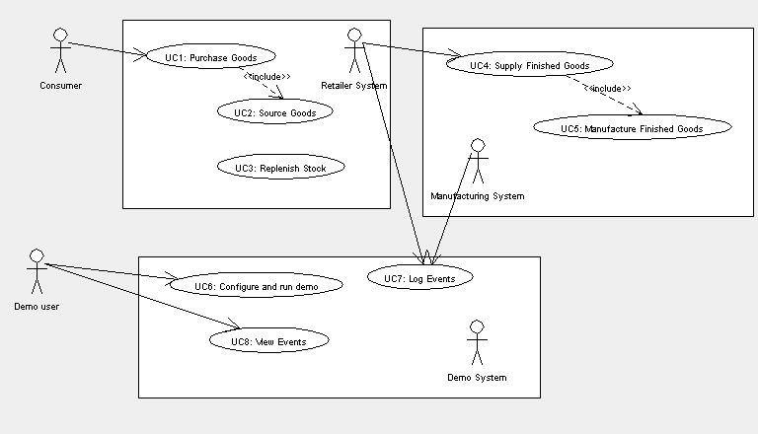
Figure 4-1: Use Case Diagram of the three systems

Overall Non-functional Requirements and Assumptions
In order to simplify the design, facilitate delivery of a demonstration application and allow the Working Group to concentrate on Web services and the implementation of the WS-I Basic Profile, the following requirements and assumptions have been defined :
- A Retailer will have exactly three warehouses (A, B, and C) that it owns.
- There will be exactly three manufacturers (Brand1, Brand2, and Brand3).
- Each manufacturer supplies exactly three products (TV, DVD, video camera). Hence there are nine valid products to be offered by a Retailer; Brand1 TV, Brand2 TV, Brand 3TV, Brand1 DVD, etc.
- All three warehouses stock all nine products.
- For demo purposes there will be one invalid product Brand4 TV. The product will be visible in the Retailer’s catalog but is not stocked (or recognized) by any warehouse.
- An order may contain multiple line items, where each line item relates to a specific product and quantity required. A product shall not appear more than once in an order.
- There are no minimum order quantities, and quantities express units of one (true for both Consumer to Retailer and Retailer to manufacturer).
- Partial shipments of a single product are not supported; either the required quantity of a product in a line item can be fulfilled in full or none are.
- The requested quantity of a product must be shipped by a single warehouse, or none are shipped i.e. it is not possible to split the shipment of a product across warehouses.
- Back orders are not supported; either the required quantity of product can be fulfilled in full by a single warehouse (points 7 and 8) or that line item is rejected.
- The Consumer’s information (payment details, address, etc.) are known to the Retailer system via an implicit logon when the demo starts.
- Payment is not demonstrated, it is assumed that a Consumer has pre-registered credit card details and billing happens out of band.
- The start of each purchase use case assumes state is set back to predefined values i.e. predefined stock levels, min/max levels, etc.
- It is assumed that all implementers will implement all use cases in the Retailer and Manufacturing Systems i.e. 1 Retailer with three warehouses (A, B, and C), and three Manufacturers (Brand1, Brand2, and Brand3.)
- Only implementation team sanctioned implementations can be configured in this demo i.e. these use cases and demo system do not provide a means for third parties to plug in their implementations.
- A manufacturer will always ship the requested number of a product to a warehouse i.e. we assume it can always manufacture the required amount.
- To maximize interoperability testing, a non-Roman character set should be used in an appropriate place. The suggestion is for the description of at least one product to be in a non-Roman text.
- When a purchase request brings a warehouse quantity to below a certain level, the warehouse makes a request of the appropriate manufacturer for more goods.

UC1: Purchase Goods

Definition

Goal of Use Case: | A Consumer goes to the Retailer website with the intent of purchasing Consumer electronic products.
Preconditions: | - Product Catalog Exists  - All state (warehouse levels etc) set back to predefined values  - Payment and address details for Consumer are known
Success Post Conditions: | - At least one product is shipped  - The Consumer is returned a Confirmation page outlining which products will be shipped  - The Retailer has requested the warehouses to ship the available goods.  - Payment from the Consumer’s credit card is triggered.
Failed Post Conditions: | The Consumer is returned an error stating that none of the items in the order can be fulfilled.
Actors: | Retailer System, Demo System, Consumer
Triggers: | This process is started by the Consumer (human interaction)

Main Success Path

Step | Actor | Description | Branches  Condition Location
1. | Consumer | The Consumer navigates to a shopping page.
2. | Demo System | The Demo System presents a shopping page, including a catalog of products.
3. | Consumer | The Consumer enters the number of each product required (i.e. changes the number from zero to a required amount).
4. | Consumer | Once happy with the quantities, the Consumer submits the order to the Retailer System via the demo system.
5. | Retailer System | Validate order. An order is rejected completely if it contains a product that does not exist. | No Such Product | ALT1
6. | Retailer System | The Retailer’s system determines which warehouse can supply each line item and asks the warehouse to ship them. |  | UC2
7. | Retailer System | The Retailer System returns the order back to the Consumer indicating which line items have been shipped and which line items could not be shipped. | Nothing Available | ALT2
8. |  | Trigger payment from the Consumer’s pre-registered card (this is a manual process in this system)
9. |  | The use case ends

ALT1: No Such Product

Step | Actor | Description | Branches  Condition Location
1. | Retailer System | The Retailer System returns an error to the Consumer, informing them that they have selected a product that does not exist. The name/brand of the product is reported to them. All items in the order are rejected.
2. |  | The use case ends in failure

ALT2: Nothing Available
Step | Actor | Description | Branches  Condition Location
1. | Retailer System | The Retailer System informs the Consumer that none of the items in the order can be shipped as no warehouse has the required quantity.
2. |  | The use case ends in failure

Activity Diagram
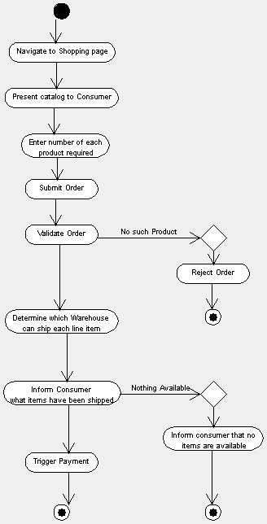

Non-functional Requirements and assumptions
At least one invalid product should be in the catalog displayed to the Consumer.

Open Issues
None.

UC2: Source Goods

Definition

Goal of Use Case: | To locate ordered goods in a warehouse and request shipment
Preconditions: | none
Success Post Conditions: | - For each line item in the order, a warehouse is selected that has the available quantity and that warehouse ships the goods.  - For line items that are accepted, the inventory levels in the shipping warehouse for that product are decreased by the quantity in the line item.
Failed Post Conditions: | There is no stock availability in any Warehouse for all of the line items in the order.
Actors: | Retailer System
Triggers: | Receipt of order from Consumer.

Main Success Path
Step | Actor | Description | Branches  Condition Location
1. | Retailer System | Present the list of line items to warehouse A and request A to ship those items it has available. |  | ALT 1
2. | Retailer System | Record the line items that warehouse A is shipping and decrement A’s stock levels for the items it will ship. | Warehouse A can’t fulfill some items | ALT 1
3. | Retailer System | The use case ends

ALT 1: Warehouse A can’t fulfill some items
Step | Actor | Description | Branches  Condition Location
1. | Retailer System | For the items that warehouse A could not ship, request warehouse B to ship those items it has available.
2. | Retailer System | Record the line items that warehouse B is shipping, and decrement B’s stock levels for the items it will ship. | Warehouse B can’t fulfill some items | ALT 2
3. | Retailer System | The use case ends

ALT 2: Warehouse B can’t fulfill some items
Step | Actor | Description | Branches  Condition Location
1. | Retailer System | For the items that warehouse B could not ship, request warehouse C to ship those items it has available.
2. | Retailer System | Record the line items that warehouse C is shipping, and decrement C’s stock levels for the items it will ship. | Warehouse C can’t fulfill some items | ALT 3
3. | Retailer System | The use case ends

ALT 3: Insufficient quantity in warehouse C
Step | Actor | Description | Branches  Condition Location
1. | Retailer System | For the items that are left, record that no warehouse can ship those items
2. | Retailer System | The use case ends.

Activity Diagram
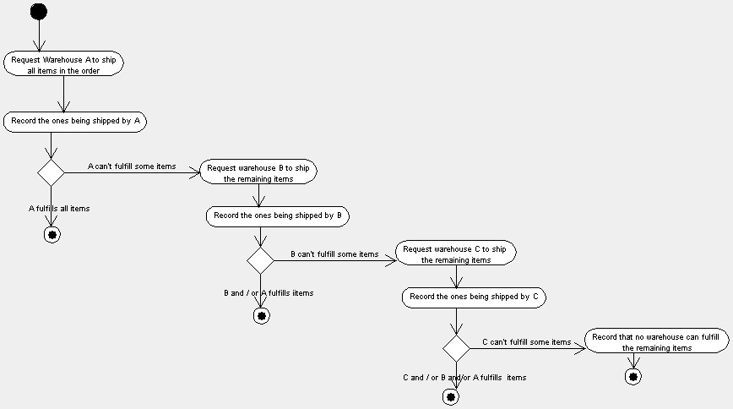

Non-functional Requirements and Assumptions
None.

Open Issues
None.

UC3: Replenish Stock

Definition

Goal of Use Case: | The Retailer System orders goods from a manufacturer to replenish stock for a particular product in a particular warehouse.
Preconditions: | The inventory level of a product in a particular warehouse has fallen below its minimum level
Success Post Conditions: | The inventory level of the product in a particular warehouse is at the maximum level.
Failed Post Conditions: | The inventory level of the product in a particular warehouse is not updated and remains under stocked.
Actors: | Retailer System, Manufacturing System
Triggers: | Triggered internally in the Retailer System for each warehouse that detects the pre-condition.

Main Success Path
Step | Actor | Description | Branches  Condition Location
1. | Retailer System | The Retailer System constructs a purchase order for the product with the necessary quantity to bring the product up to its maximum level for that warehouse.
2. | Retailer System | Place Order. The Retailer system submits the purchase order to the relevant Manufacturing System (Brand1, Brand2 or Brand3) as dictated by the product.
3. | Manufacturing System | Validate Order | Malformed order or invalid product or invalid quantity | ALT 1
4. | Manufacturing System | Send an acknowledgement back to the Retailer System
5. | Manufacturing System | The Manufacturing System constructs a shipment of the requested quantity of product. | unconditional | UC4
6. | Manufacturing System | The Manufacturing System ships the goods and sends shipping notice to the warehouse. The shipping notice is the business level reply to the purchase order.
7. | Retailer System | When the Retailer System receives the shipping notice, an acknowledgement is sent back to the Manufacturing System.
8. | Retailer System | Upon receipt of the shipment, the warehouse updates its product inventory level based on receipt of the shipped order.

ALT1: Malformed Order or No Such Product or Invalid quantity

Step | Actor | Description | Branches  Condition Location
1. | Manufacturing System | The Manufacturing System rejects the order either due to a malformed order, a request for a product that doesn’t exist, or a request for an invalid quantity (such as zero or more than the max level for that product). A reply, containing an application error message/code, is sent back to the Retailer System.
2. |  | The use case ends in failure

Activity Diagram
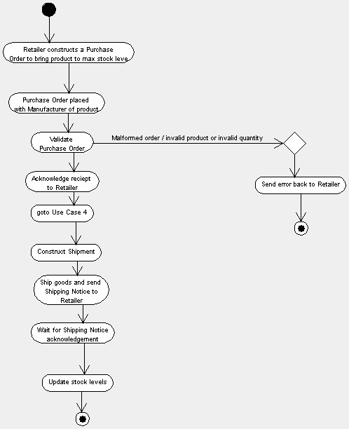

Non-functional Requirements and Assumptions
None.

Open Issues
None.

UC4: Supply Finished Goods

Definition

Goal of Use Case: | A manufacturer processes a purchase order from a warehouse.
Preconditions: | Min < Manufacturer’s Finished Goods Inventory Level < Max
Success Post Conditions: | The purchase order is fulfilled and finished goods shipped to Retailer’s warehouse.
Failed Post Conditions: | The purchase order is not fulfilled.
Actors: | Manufacturing System, Retailer System
Triggers: | Receipt of a purchase order.

Main Success Path

Step | Actor | Description | Branches  Condition Location
1. | Manufacturing System | Check Inventory. The manufacturer checks its finished goods level to determine if it can fulfill the order. | Insufficient goods | UC5
2. | Manufacturing System | Ship Order. The manufacturer ships the finished goods to the retailer’s warehouse and sends the warehouse a shipping notification.
3. | Manufacturing System | Update Inventory. The manufacturer updates its finished goods inventory level based on the quantity being shipped in step 3. If the minimum finished goods threshold is exceeded, manufacture more, which is defined by UC5. | Minimum threshold exceeded | UC5

Activity Diagram
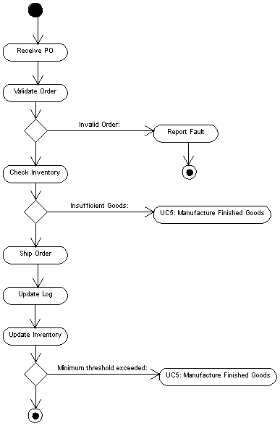

Non-functional Requirements and Assumptions
No multi-line orders are accepted i.e. an order relates to a single product (finished good).

Open Issues
None.

UC5: Manufacture Finished Goods

Definition

Goal of Use Case: | The goal of this use case is to initiate a production run for the purposes of replenishing the stock levels of a specified product.
Preconditions: | Stock levels for the manufactured product are not sufficient to meet a purchase request or stock levels have fallen below the minimum level for the product.  The necessary parts and their quantities for a production run are available.
Success Post Conditions: | The stock level for the manufactured product will be at the maximum level.
Failed Post Conditions: | Stock levels will be left unchanged.
Actors: | Manufacturing System
Triggers: | Manufacturer is requested to supply finished goods

Main Success Path
Step | Actor | Description | Branches  Condition Location
1. | Manufacturing System | Determine part list and quantities required to manufacture product.
2. | Manufacturing System | Start production run.
3. | Manufacturing System | Wait for production run to finish.
4. | Manufacturing System | Stack finished goods in (manufacturer’s) warehouse.

ALT 1: Invalid Request

Activity Diagram
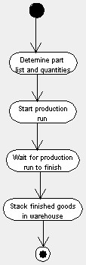

Non-functional Requirements and Assumptions
- A pre-defined unit production time exists for each product.
- Each production run takes exactly the calculated time to complete.

Open Issues
None.

UC6: Configure & Run Demo

Definition

Goal of Use Case: | Allow the person operating the demo (a.k.a. demo user) to select from among a list of different, equivalent web service implementations.
Preconditions: | There is more than one implementation of each web service to choose from.  Each web service that is offered has been approved by WS-I’s Sample Applications Working Group.
Success Post Conditions: | A configuration is selected and the demo is started.
Failed Post Conditions: | 1. Incorrect or incomplete configuration selected  2. Endpoints not available
Actors: | Demo User, Demo System
Triggers: | Demo User navigates to the WS-I demo web page.

Main Success Path
Step | Actor | Description | Branches  Condition Location
1. | Demo System | Present Choices. The system presents the demo user with a number of configuration options. It is assumed that the system will not present any invalid options, and that all combinations of options are valid.
2. | Demo User | Select Options. All options will have randomly generated default selections. The demo user selects implementations of individual web services. Each web service in the demo will be implemented by one or more vendors.
3. | Demo System | Generate ID. The Demo system generates a unique ID which is used to retrieve the log entries for different (concurrent) demo users.
4. | Demo User | Start Demo. The demo user records the generated ID and acknowledges receipt of the ID to the system. This acknowledgement causes the system to start the demo, branching to UC1. | Demo user receives ID. | UC1

Activity Diagram
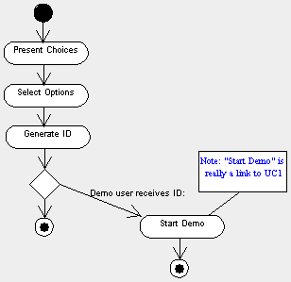

Non-functional Requirements and Assumptions
Use UDDI to discover the web service implementations to be presented to the Demo User (step 1, main success scenario).

Open Issues
None.

UC7: Log Events

Definition

Goal of Use Case: | The goal of this use case is to log events relating to the execution of other use cases for the purpose of enabling a Demo User to view these events. In this way the Demo User will be able to see which web services have been consumed by a given operation and the outcomes of those web services.  The events should be able to be viewed at any time. This may mean that for asynchronous operations one or more web services may still be executing.
Preconditions: | none
Success Post Conditions: | Event is logged to the repository.
Failed Post Conditions: | - An entry will be added to the log, which will include an error code and description outlining the cause of the failure. Or  - Repository is not available
Actors: | Any web service system as Initiator, Demo System.
Triggers: | Initiation, termination or any significant point in the execution of one of the core use cases.

Main Success Path

Step | Actor | Description | Branches  Condition Location
1. | Retailer System or Manufacturing System | Sends a request to the Demo System to log events.
2. | Demo System | Receives request to log events.
3. | Demo System | Validate request. | Invalid request | ALT 1
4. | Demo System | Logs events, including user ID, initiating server ID, responding service ID, unique demo ID, use case ID, date/time of operation and other transaction details. Transaction details can be passed as a long string. | Repository not available | ALT 2

ALT 1: Invalid Data
Step | Actor | Description | Branches  Condition Location
1. | Demo System | Log reason for failure (e.g. XML fragment does not conform to schema) | Repository not available | ALT 2
2. |  | Terminate process.

ALT 2: Repository not available
Step | Actor | Description | Branches  Condition Location
1. |  | Terminate process.

Activity Diagram
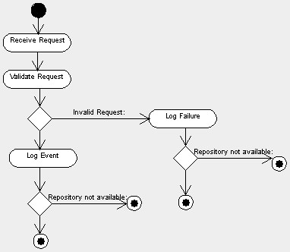

Non-functional Requirements and Assumptions
Call to log statistics will use the Document Style One-way Message Scenario.

Open Issues
None.

UC8: View Events

Definition

Goal of Use Case: | The goal of this use case is to allow the Demo User to view the log of events that occurred as a result of running the demo.
Preconditions: | Events related to the demo user are clearly marked in the log.
Success Post Conditions: | Events are displayed
Failed Post Conditions: | Events cannot be located
Actors: | Demo User, Demo System
Triggers: | Demo User navigates to an appropriate place in the user interface.

Main Success Path
Step | Actor | Description | Branches  Condition Location
1. | Demo User | The Demo User requests the display of events related to a demo.
2. | Demo System | Extracts from the log all the entries related to the latest demo run by the Demo User. | Unable to access the log | ALT 1
3. | Demo System | The Demo System returns to the Demo User a list of the relevant events for them to view.

ALT 1: Unable to access the log
Step | Actor | Description | Branches  Condition Location
1. | Demo System | Report back to the Demo User that the events cannot be displayed.
2. |  | The use case ends unsuccessfully

Activity Diagram
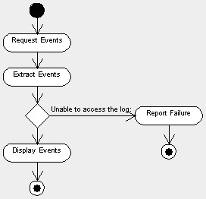

Non-functional Requirements and Assumptions
None.

Open Issues
None.

